**Reading image files**

**Objective**

1. Modify the program to receive file name from command line

2. Modify the programs to calculate basic statistics of specified image

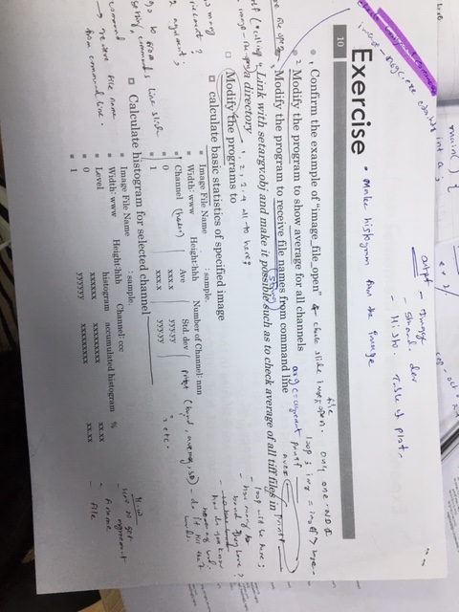

1. **Modify the program to receive file name from command line**

**Code description:**

//Define functions image.c and image.h for handling images on memory and some image functions which are in library which link by “image.h” and “imgio.h” for handling file I/O*/

#include<stdio.h>

#include<math.h>

#include "image.h"

#include "imgio.h"

//Function statement

double img_ave(u_char **pix, int w, int h);

//main part

void main()

{

//declare variable, input image is pointing to the img (*img), image file pointing to imgf(*imgf) and average value is double;

IMAGE *img;

IMAGE_FILE *imgf;

double ave;

// calling image file open function. Three inputs, file name “color.hdr”, read only, buffering image data

printf("calling: image_file_open\n");

if ((imgf = image_file_open("color.hdr", IMAGE_RDONLY, IMAGE_BUFFERED)

) == NULL) //if memory not enough, exit the program

{

printf("image_file_open error\n");

exit(1);

}

printf("main:w:%d h:%d nchan:%d\n", imgf->w, imgf->h, imgf->nchan);

img = imgf->image;

//Calling average function and print put the result

printf("calling: ave\n");

ave = img_ave(img->data[0], img->w, img->h);

printf("main:ave = %lf\n", ave);

//Close input file image

printf("calling:image_file_close\n");

image_file_close(imgf);

}

/*Function to calculate average value of input image*/

double img_ave(u_char **pix, int w, int h)

{

int i, j;

double ave = 0;

for (i = 0; i < h; i++)

for (j = 0; j < w; j++)

ave += pix[i][j]; //Sum of value

ave /= w*h;

return ave;

}

**Output:**

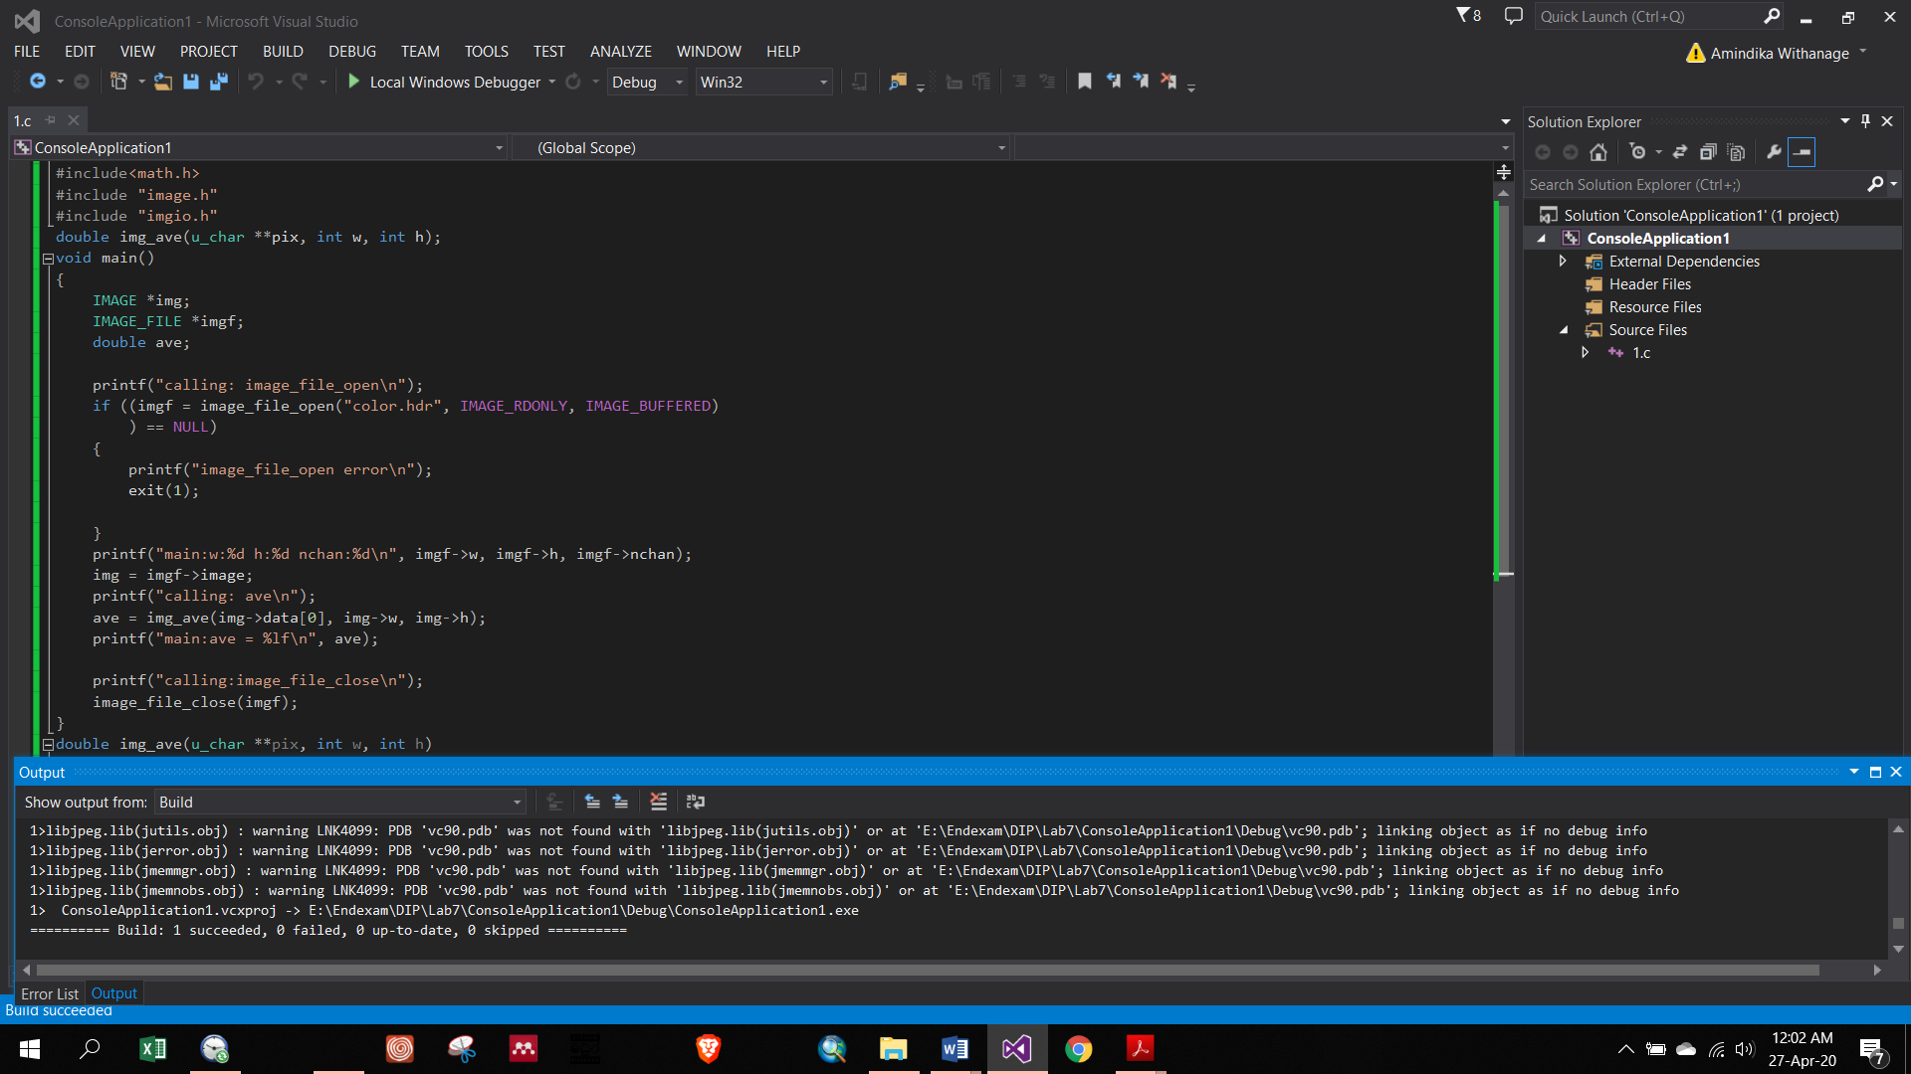

As output I couldn’t get average through code was run.

